Bitcoin narxini bashorat qiluvchi model

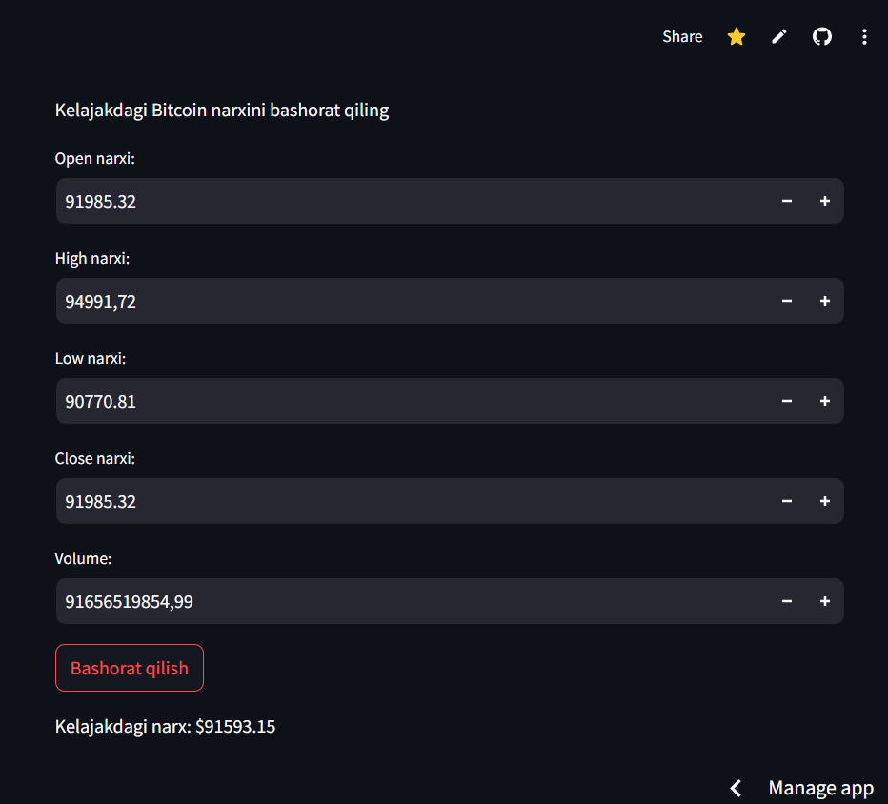

<https://bitcoinbashorat.streamlit.app/>

sayt linki

<https://github.com/AlibekSerikbayev/Bitcoin_bashorat>

github likni

<https://colab.research.google.com/drive/1dNzEzxK4SfObUxxlwp4dftJFDDiwX2VA?usp=sharing>